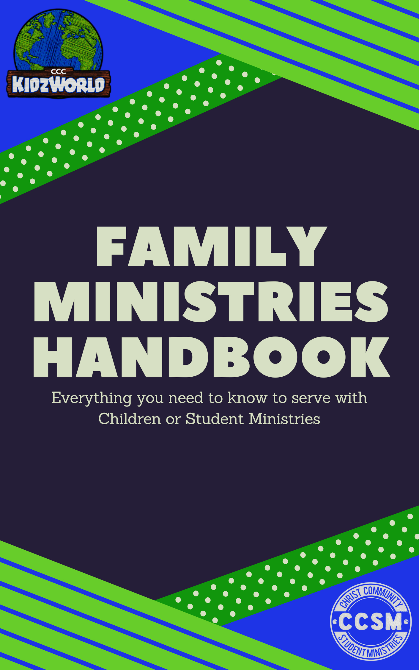

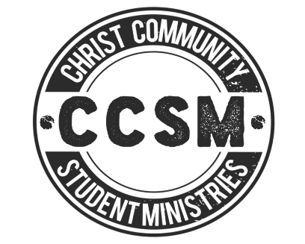

FAMILY MINISTRIES HANDBOOK

Welcome! We are so excited that you are considering serving on the Family Ministries Team at Christ Community Church! CCC is a Family of Grace on Mission with Jesus, bringing Glory to God – and that is the same vision shared by the family ministries department. Our goal is to provide a safe and loving atmosphere for children, students and families to be equipped & discipled to join us on mission where we live, work and play.

It is important that everyone on our team understands that they are a vital part of the discipleship plan and process for our church and seek to fill our teams with people that know and love Jesus and His kids. In this handbook you will find descriptions of all available opportunities to serve in children’s ministry plus all ministry policies and procedures. Please make sure to review them carefully and write down any questions that you might have.

On our website, www.christcommunityfm.com, you will also find a tab for resources under the children’s ministry tab. There you will find links to several videos that describe the Why behind children’s ministry, as well as a link to check out the curriculum that we use. We encourage you to watch some of them and be encouraged & excited about how God can work in and through you in the lives of children and their families.

If you have any questions, we would love to hear from you! Please let us know. You will find contact information below for our team.

Kevin Gladfelter, Family Ministries Director
E-mail: kevin@cccfortmyers.org
Office: 239.939.5656 (Monday – Thursday, 9am-4pm)
Call or Text: 336.692.1411 (Text will be the best)

Leanna Gladfelter, Office Administrator
E-Mail: leanna@cccfortmyers.org

Family Ministries Overview

When you hear Family Ministries at CCC, it includes several different ministries covering a wide range of ages from birth – high school. Our children’s ministry is known as KidzWorld and our student ministry is known as, CCSM (Christ Community Student Ministries).

KidzWorld Nursery

Ages: Infant – Age 3
Our nursery area is carefully designed to meet the needs of our youngest friends and has furniture, toys and play areas that are age appropriate. Nursery is open each Sunday morning during our 10:30 AM worship service, as well as various other church services and events.

KidzWorld: Kid’s Church

Elementary KidzWorld: Ages 4 (potty trained) – 5th Grade
At CCC we feel that it is important for children to be a part of worship with their parents, so our children’s church begins after that. All kids in K-5 attend the worship portion of the service with their parents and then are dismissed from the service and walked over to the FLC (Family Life Center) for KidzWorld once the sermon begins to they can receive an age appropriate Bible lesson. This time includes Bible story, application activities, and praise and worship. 4 year olds have the option between Nursery and Kid’s church and can be evaluated on a case by case basis.

Equip

This is CCC’s Christian Education classes. There are classes available for all ages! These classes meet most Sundays at 9:20 AM.
Adults: Various studies for adults

CCSM – Christ Community Student Ministries

Students that are in 6th – 12th Grades. They meet on Wednesday nights for a time of fellowship, games, bible study, worship and small groups.

Opportunities to Serve

The Bible teaches that God has given the His people many gifts and talents to accomplish the mission that He has in sharing the gospel with the world. We love to give the church body opportunities to use those gifts in service to Jesus and others. Below are several ways that you can plug into the Family Ministries Team. Some positions, like lead teachers for example, require church membership or some time of observation, but there are many opportunities called First Serve Opportunities, to jump right it. If you are serving as a small group leader and teacher, it is also important that you are seeking to grow as a disciple, spending time investing in your relationship with Jesus and a part of an accountable spiritual community.

Team Meetings: If you serve on the Family Ministries team, plan to attend quarterly training meetings and also quarterly team meetings. These moments together are so important as we seek to provide training for our curriculum, child safety, discipleship and also pray, build community and cast vision. We ask that you make every attempt to be in attendance.

KidzWorld
Sunday Mornings & Special Events
Sunday lessons are emailed the Monday-Tuesday before you teach. All supplies are provided and found on a cart in the KidzWorld Check-In Room. Each age group/class has a team of teachers that serve together and rotate monthly. This helps develop consistent relationships with kids and families.
- Nursery Team
- Elementary Team Teachers
- Teachers Assistant (Review the lesson prior, assist lead teacher)
- Substitute
- Office Help (First Serve Opportunity)
- Check-In (First Serve Opportunity)
- Hall Monitor (First Serve Opportunity)

Equip
Sunday Mornings
All curriculum copies and basic supplies are provided. Lead teacher receives 5-8 weeks of lessons at a time and teacher assistants help during teaching time with all classroom activities. Some teacher assistant positions are First Serve Opportunities!!
- Nursery
- Younger Elementary Teacher Assistant
- Older Elementary Teacher Assistant

CCSM
Student ministries at CCC is a highly relational ministry. We have students from all types of personalities and cultures! Because the variety of students is so big, we love for a variety of ages, personalities, and cultures present in our adult leaders as well!

- Small Group Leaders – Male & Female (Wednesday Nights)
During our midweek youth group service, students break into small groups based on age and gender to build community and provide opportunities for discipleship and to engage in deeper conversation and life application of the Bible. Small group leaders are expected to build relationship with students, be consistent, make contact with students in their group outside of church, review small group leader notes weekly.
- Transportation (Wednesday Nights & Sunday Mornings) Many of our students need a ride to get to church and are spread all over Fort Myers.
- Snack Coordinator – Wednesdays (First Serve Opportunity) Pick-up snack and greet students as they arrive to get snack (CCSM purchases snack)
- Mentors - meet with a group of 2 students weekly or bi-weekly for deeper discipleship, Bible study and accountability.

Discipleship Plan/Goals

At Christ Community, we are committed to being disciples of Jesus that help make disciples of Jesus. In the family ministries department, we seek to come alongside parents and families to help them instill these same discipleship outcomes in their children and students. Our ministry seeks to be like the ministry explained in Family Ministry Field Guide:

“The kind of family ministry that I envision is a movement toward equipping Christian households to function as outpost of God’s mission in the world. Through family ministry, families become contexts where Christian community is consistently practiced with the goal of sharing the good news of God’s victory far beyond our families. The gospel is rehearsed and reinforced at church so that God’s truth can be revealed to the World. This isn’t about retaining young adults on the attendance rolls; it’s about coordinating families around a shared, Spirit motivated perspective on parents and children.”

Every program, event, class, curriculum choice and resource provided fits with the goals of helping to move people along a discipleship path to begin and then develop a deeper relationship with Jesus. We seek to develop disciples of Jesus who have a heart to help others become disciples.

Application Process

At CCC, providing a safe place for children, students and families to grow and learn about Christ is of upmost importance to us. Because of this, our application process to serve is thorough and ongoing. There are several steps to take before you begin serving with children and students. Check out the process below.

- Starts with a Conversation
Those interested in serving in Family Ministries should connect with CCC’s Family Ministry Pastor, Kevin Gladfelter. Connect via a Connection Card, phone call, e-mail, face to face, coffee, FaceTime, Skype – you name it. We love to hear your heart and how God is moving in you to serve with the young people at our church. This is a great way to find out what opportunities there are for you and where you might best fit.

- Application
After you connect with Kevin, he will e-mail you an online application form to complete. Make sure you answer every question and of course let us know if you have any questions of your own. This process helps us make sure that we plug you in to the right spot and helps ensure that you are ready to serve. All applications are confidential and only view by ministry staff and leadership.

- References
Your application asks for e-mails for 3 references. These are important and required. We will need current e-mail addresses for 3 people that are not your family and at least 1that do not attend Christ Community Church. References can also be requested again after 4 years to keep fresh files.

- Background Check
We run a criminal background check for every person that interact with our students and children. Each background check is confidential and reviewed by ministry staff only. We repeat this process every 2 years to maintain the highest standards of protection for our children and families.

Communication & Scheduling

We communicate in 2 main ways with our team: Email & Facebook Group. Once you become a part of our team, you are added to the Facebook group and our email list.

Facebook: This is a place for us to connect & communicate. We post prayer requests, needs, schedules, announcements, training and more on here. It is a central hub for all things Family Ministries.

Schedule: Kevin handles all scheduling for KidzWorld. We post our monthly schedule for review on the Facebook group before the month begins. Please make sure to check your schedule and let us know if you need to switch days.

Communicate: We want to hear from you. If you’re going to be absent, please inform your ministry director as a soon as possible. We don’t like surprises. In addition, we value your constructive feedback.

CCSM

Communication in student ministries happens via email, text message and Instagram. Parent communication happens via email and Facebook.

Child Safety Training

At CCC making sure that we can adequately care for and supervise the children and students in our ministries is of upmost importance. We also want to provide appropriate accountability for all student and children’s ministry workers. Each classroom should have at least 2 approved CCC leaders for each ministry event or service. We understand that at times this isn’t always a possibility. When the case arises that there is only one teacher in a classroom, we have half cut doors that stay open and windows for each classroom as well as someone who is always at check-in and floating in the hallways.

We love and encourage male volunteers to serve in children & student ministries. In KidzWorld, a male volunteer should never be in a classroom alone with children. There are also policies regarding bathroom visits, see below. In CCSM, any volunteer or leader should never be with a member of the opposite sex alone. As students arrive in both age groups and we have lower numbers, the top half of doors or the full door should always be open.

Basic safety guidelines

- Try to never be alone with a child
- Male leaders may not change diapers
- Male leaders can only assist female leaders if taking older children to the bathroom (male leaders cannot assist children in the bathroom)

Appropriate Touch
It is our hope that KidzWorld is a warm, welcoming and friendly place. We greatly value the safety of our kids, failure to comply with these guidelines are grounds for immediate dismissal.

Proper Touch
Physical contact should be age and developmentally appropriate and is only appropriate when done publicly.

- Hugging can only be done if the child initiates the contact. Never allow full contact (body to body) hugs. Rather distance your body from the hug, or give the child a side-to-side hug. Sometimes it may be best for you to initiate a high-five rather than invite a hug.
- Extended hugging; tickling or prolonged physical contact of any kind is not appropriate.
- A light touch to a hand, should or back when encouraging is acceptable.
- Lap sitting is only appropriate for children under two years old. If a child is insistent in sitting in our lap, move them to sit next to your or sit on your knees so they are not able to sit in your lap.
- Many children who are sad or upset can be comforted best by being held. Holding children is only appropriate in Kindergarten or younger.
- Never touch a child in any area that would be covered by a bathing suit (except when changing a diaper or properly assisting a child in the restroom).
- Never kiss a child or coax a child to kiss you.
- Never allow a child to touch you in a way that is inappropriate.

Our appropriate touch policies are for the protection of our children and volunteers. When serving as a volunteer, you must observe these policies even with your own children who may be in your class (other observers may not know that you are the parent and we want to display excellence even in appearances).

Diaper Change Policy
During diaper changes, please only use the diapers and wipes that are provided by the parents. In the case of an emergency and the parents have not provided any, please use the unscented wipes provided by CCC. If there are no diapers, we have some but not ever size, parents may need to be contacted. Our check-in software allows us to text parents when they are needed in nursery. You can send your classroom helper to check-in or text Whitney or Marcia for assistance. Also, you may send a teacher to have the person floating in the hallway to get a child’s parent from the service.

Gloves – all volunteers should wear gloves when changing a diaper. This is not only for the leaders’ protection, but the child’s also. We never know what a child could be sensitive to and do not want to cause unnecessary reactions.

Changing tables should be cleaned after a diaper is changed. Please use the Clorox wipes or the alcohol changing table spray located above the changing area. More about this in the classroom cleanliness section below.

Bathroom Policies
Below are bathroom policies for the various bathrooms our kids use on a regular basis. Never allow yourself to be in a bathroom with a child alone. Only women may assist or escort children to the bathrooms.
Bathrooms within Early Childhood Classrooms

- Only allow one child in the bath room at a time
- If a child can go on their own, let them (just stand by the door ready to help if needed.)
- If a child needs help or hasn’t finished up after some time, talk through the door or slightly crack the door so you can talk without looking.
- If your assistance is required, ask another volunteer to stand at the door and watch you as you assist the child. Never are you to be alone with a child in the bathroom.

Bathrooms outside of Elementary Classroom

- Before allowing kids into the bathroom, check to make sure there are not adults or teenagers in the room. While kids are using the bathroom, do not allow adults or teenagers to enter.
- Line kids up along the wall outside the bathroom allowing a few in at a time.
- You must have another Adult with you
- Do not let the children close the door all the way or lock the door.
- If a child needs assistance, only enter the bathroom with another adult in the doorway watching you.
- Although a male can accompany a female adult leader on bathroom duty, the male cannot assist children in the bathroom.
- If the bathroom is within line of sight of the elementary room, elementary children may walk to the bathroom in a group of two to three. Before letting children leave the room, a volunteer must first sweep the bathroom to ensure that another adult or teenager is not in the bathroom.

Please help us prevent the spread of illnesses by washing or sanitizing your hands:
- When you first arrive in a room
- After a diaper change
- After accompanying a child to the restroom.
- After contact with body fluids (wiping a child’s nose, etc.)
- Before handling food
- Whenever else is needed
Please instruct children to wash their hands:
- After using the restroom
- Wiping their nose
- Before eating

Cry Policy
Children sometimes have a hard time being away from their parents. We work hard to help families with this and the majority of the time, little ones calm down a few minutes after mom and dad are out of sight. However, we do not want to leave a child crying for longer than 10 minutes. If the child is still crying after 10 minutes, we will need to have their guardian come back and help them transition or take them to the wiggle room where they can still here the service.

Arrive on Time
All volunteers should arrive no later than 15 minutes prior to their volunteer service time. This time will allow for preparation and connection with those you are serving with and allow those serving before you to leave.

Check-In/Pick-Up
All children are to be checked in. If a parent drops a child off to your classroom and they do not have a check-in sticker on, please have the parents check their child in and bring them back.

Check-In Stickers are very important for you. They will have the child’s name, age, classroom, and any allergy information. It is important to check this each time a child enters your classroom. IT also will have an image that will match the parents pick up sticker, as well and the same number/letter code.

Injuries
Classrooms are equipped with First Aid Kits. Please complete an incident report for all injuries. There are copies located at the check-in desk.

Medication
We are not authorized to administer any over the counter or prescription medications. In the event a child needs more attention than we can provide, the parent will be notified.

Emergencies
Each classroom is equipped with a flipbook that has directions for how to handles emergency situations handing on the wall. A copy is also provided in the new leader packet for your review.

Well Child Policy
In order to promote health and wellness in all children, KidzWorld is for well children only. Therefore, if a child has any of the following symptoms, please do not bring them to the nursery.

- Any degree of fever
- Vomiting
- Diarrhea
- Unexplained or contagious skin rash
- Bleeding/wet diaper rash
- Chronic Cough
- Runny nose (yellow/green discharge)
- Eye infection
- Pink Eye
- Parasites (lice)

If a child enters KidzWorld, and one of the above symptoms are found, the parent will be contacted.

Child Abuse Information & Policies

The National Committee for Prevention of Child Abuse designed the definitions below.

Physical Abuse
Physical abuse can be defined as a non-accidental injury, which may include beatings, violent shaking, human bites, strangulation, suffocation, poisoning, or burns. The results may be bruises and welts, broken bones, scars permanent disfigurement, long-lasting psychological damage, serious internal injuries, brain damage or death.

Physical/Emotional Neglect
Physical/Emotional neglect is the failure to provide a child with basic needs including food, clothing, education, shelter, and medical care; also abandonment and inadequate supervision.

Sexual Abuse
Sexual abuse is constituted through the sexual exploitation of a child by an older person as in rape, incest, fondling of the genitals, exhibitionism or pornography. It may be done for the sexual gratification of the older person, out of a need for power or economic reasons (such as prostitution, etc.)

Emotional Maltreatment
A pattern of behavior that attacks a child’s emotional development and a sense of self-worth, such as constant criticizing, belittling, insulting, manipulation. It can also be defined as providing no love, support, or guidance for the child.

Reporting Suspected Child Abuse

- Familiarize yourself with the definitions and descriptions of child abuse listed above.
- If you suspect that a child involved in any of the programs of Christ Community Church has been abused, the following steps are to be followed: Report the suspected abuse to a member of the Ministry staff.
  - Do not interview the child regarding the suspected abuse. This could be considered leading the child.
  - Do not discuss the suspected abuse with other volunteers, parents, etc. All information regarding the child should be kept confidential with your ministry supervisor and the proper authorities.
  - You may be asked to complete a Suspected Child Abuse Report. Confidentiality will be maintained as much as possible. This form will be returned to your ministry supervisor.

Student Ministries: Texting & Social Media

Snap-Chat: We ask that no leader follow or interact with students via the snap chat app. This app provides no accountability to protect the leader or the student from inappropriate conversations or photos, so we just avoid it all together.

Personal Social Media: We love social media and the opportunities it gives us to connect and share our lives with families and friends. As leaders who like Paul say to our students “Follow me as I follow Christ”, we need to be wise with our social media posts. We ask that you not post pictures or share posts that are questionable or could be a stumbling block from those we lead.

Communicating with Students: This is so important! Most ministry doesn’t happen on Wednesday night or Sunday morning. It happens in the midst of real life. Our prayer is that you are connecting with students and their families. Please have boundaries and be wise as you do so. If possible, do not delete conversations with students from your phone. If you receive something that is questionable, or you aren’t sure, share it with leadership as soon as possible. If a student reveals to you any plan or attempt to harm themselves or others – please contact Kevin at 336-692-1411 immediately. While we want to build relationships of trust, their safety and that of others is important. We also seek to partner with parents. We want to make sure we let them know of any concerning things with their children.
Notes:
_______________________________________________________________________________________________________________________________________________________________________________________________________________________________________________________________________________________________________________________________________________________________________________________________________________________________________________________________________________________________________________________________________________________________________________________________________________________________________________________________________________________________________________________________________________________________________________________________________________________________________________________________________________________________________________________________________________________________________________________________________________________________________________________________________________________________________________________________________________________________________________________________________________________________________________________________________________________________________________________________________________________________________________________________________________________________________________________________________________________________________________________________________________________________________________________________________________________________________________________________________________________________________________________________________________________________________________________________________________________________________________________________________________________________________________________________________

